**(SECJ1013) PROGRAMMING TECHNIQUE 1**

**SEM 1, SESSION 2023/2024**

**ASSIGNMENT 1**

**INSTRUCTIONS TO THE STUDENTS**

* This assignment must be done **in a group of two**.
* Any form of plagiarism is **NOT ALLOWED**. Students who copied other's assignments will get **ZERO** marks (both parties, students who copied and students who shared their work).
* Please put your **name and matric number** and your member's **name and matric number** on the front page of the submitted file.

**SUBMISSION PROCEDURE**

* Please submit this exercise no later than **November 05, 2023, Sunday (00:00 MYT)**.
* Only one file is required for the submission (the file with the extension **.pdf**).
* Only **ONE** submission per pair (group).
* Submit the assignment via the UTM's e-learning system (<https://elearning.utm.my/23241/>).
* Note: Draw your flowchart using any appropriate drawing tools such as Microsoft Visio, Lucid chart (<https://www.lucidchart.com/pages/examples/flowchart-maker>), and draw.io (<https://app.diagrams.net/>).

# SET 1

Based on the output below, provide your answers on how you designed the program. Make sure to include either pseudocode or flowchart until you write the codes for the program to generate the output.

***Note:*** The font in **bold** shows input entered by the user.

**Output**

Enter member 1 name: **your group's first member name**

Enter member 1 matric number: **your group's first member matric number**

Enter member 2 name: **your group's second member name**

Enter member 2 matric number: **your group's second member matric number**

Assignment 1

-----------------

Course: SECJ 1013 Programming Technique 1

Section: your section number

Program: your program name (e.g., Bachelor of Computer Science (Bioinformatics / Data Engineering / Software Engineering))

Members:

your group's first member name (your group's first member matric number)

your group's second member name (your group's second member matric number)

# SET 2

The flowchart below represents a nested loop to collect data and calculate the average rainfall over a period of years. First, the program should ask for the number of years. The outer loop will iterate once for each year. The inner loop will iterate 12 times for each year. Each iteration of the inner loop will ask the user for the inches of rainfall for that month. After all iterations, the program should display the number of months, the total inches of rainfall, and the average rainfall per month for the entire period.

Input Validation: Do not accept a number less than 1 for the number of years. Do not accept negative numbers for the monthly rainfall.

Fill in the blank graphical symbols with question mark (?) and Roman numbers in the flowchart below with appropriate instructions. Redraw the flowchart below with your answers.

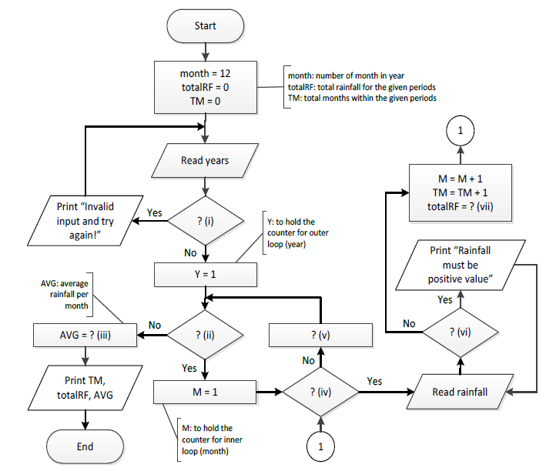

# SET 3

Based on the C++ program below, Identify and correct any syntax and/or logical errors in the program by writing the corrected statements in the table below. Only the corrected statements need to be written in the table.

|  |  |
| --- | --- |
| 1  2  3  4  5  6  7  8  9  10  11  12  13  14 | #include <iostream>  int main() {  int i = 25;  while (i > 0) {  for (j = i; j > 0; j =- 5) {  if (i + j) % 4 != 0;  continue;  else  cout << "j = " << --j;  << " i = " << i << endl;  }  i =/ 2;  }  } |

|  |  |
| --- | --- |
| **Line** | **Corrected Statements** |
|  |  |

# SET 4

Convert the pseudocode below to a simple C++ program and provide the output as shown below.

***Note:*** The font in **bold** shows input entered by the user.

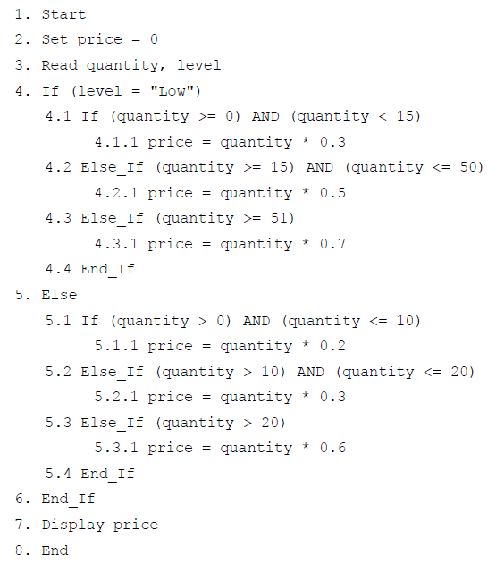

Note:

“If” using the command “if”

“Else_If” using the command “else if”

**Output for Example 1 Output for Example 2**

Enter the quantity and level: **51 Low** Enter the quantity and level: **0 Medium**

Price: RM 35.7 Price: RM 0

**Output for Example 3**

Enter the quantity and level: **20 High**

Price: RM 6